Zipping Sliced Files
Modify your previous program to also compress the bytes while slicing parts and decompress them when assembling them back to the original file. Use GzipStream.
Tip: When getting files from directory, make sure you only get files with .gz extension (there might be hidden files).
Source File | Compressed & Sliced | Decompressed & Assembled
parts = 5 | 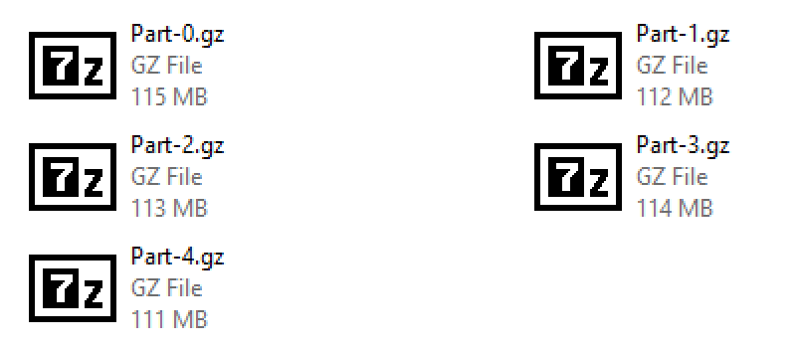 | 